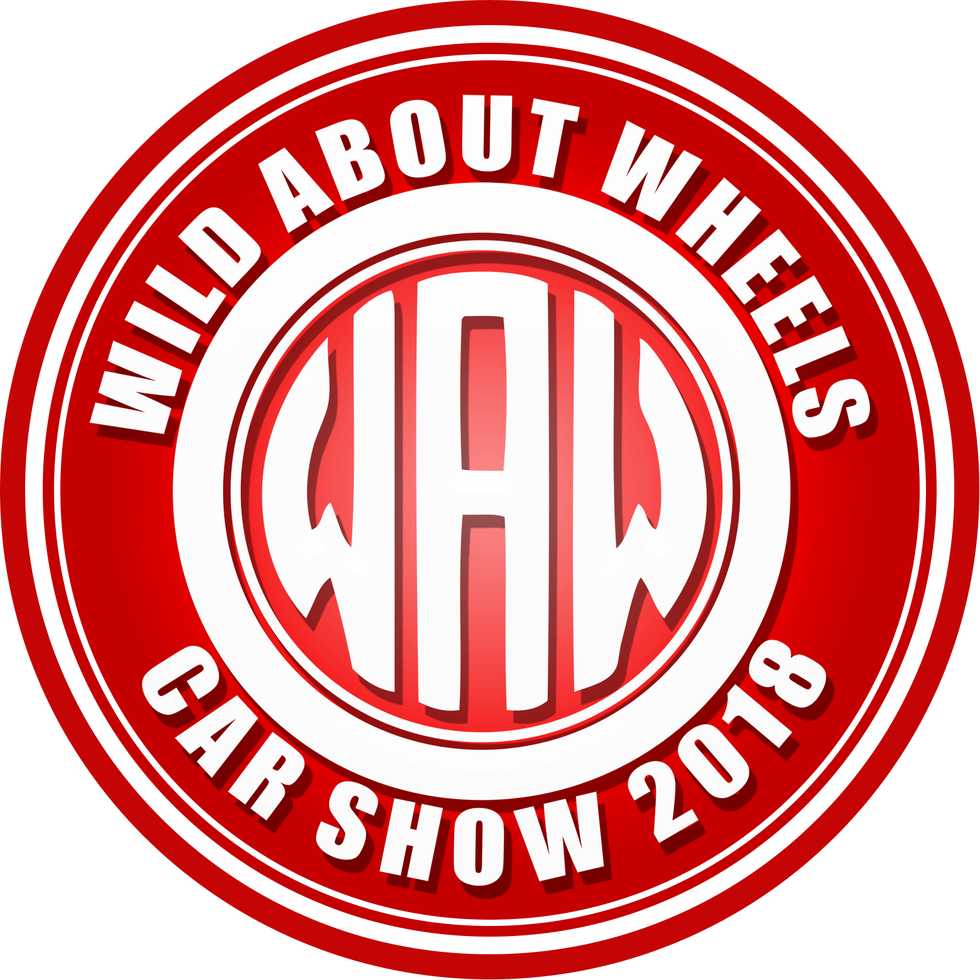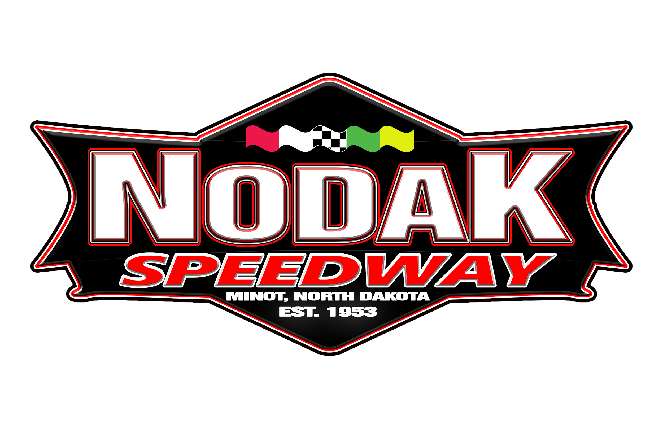
Wild About Wheels Car Show
Car Registration Form

February 10th and 11th 2018

NAME:______________________________________________________
ADDRESS: __________________________________________________________________
CITY, STATE: _______________________________________________________________
ZIP CODE: _______________________ PHONE: __________________________________
EMAIL: ___________________________________
HOW DID YOU HEAR ABOUT THE SHOW: _______________________________________________________
_______________________________________________________
WHAT CAR CLUB DO YOU BELONG TO: ____________________________________________________________________
NOTICE: THIS IS A 2 DAY CAR SHOW. CARS ARE TO REMAIN ON DISPLAY FROM OPEN (FEB 10TH AT 10AM) UNTIL THE END OF THE SHOW, FEB 11TH AT 5PM.

2018 Car Show Hours
Saturday, February 10th 10am-6pm
Sunday, February 11th 10am-5pm
CAR INFORMATION
(PLEASE INCLUDE A PICTURE)
TYPE OF CAR: (Race Car, Classic Car, Cliffhanger, Drag Car, Motorcycle, etc)
__________________________________________________________________________
MAKE:______________________________________________________
MODEL:______________________________________________________
YEAR:______________________________________________________
COLOR:______________________________________________________
THERE WILL BE A LIMITED NUMBER OF SPACES Please submit forms to racenodak@gmail.com or P.O. Box 702 Minot, ND 58702 For more information or questions call Nodak Speedway at 701-822-7223

